Rotary Club of Kathmandu Mid-Town
Breakfast Chatter




6 Janaury 2012 The Weekly Bulletin of Rotary Club of Kathmandu Mid-Town Bc-1.06/011-12

District: 3292 Web: www.rotarymidtown.org.np Club Id : 26776

JANUARY IS THE ROTARY AWARENESS MONTH
Awareness is an important part of the Rotary work that can be divided into two parts.
It is imperative that members are well aware of Rotary’s goals – that Rotary is an organization that works for peace and better understanding between people.
The other part of Rotary awareness is the sharing of information outside of our organization.

30 December, Friday:
Guest Speaker Dr Gita Lawot Pfau spoke on the topic “Ensuring Abortion Law as Reproductive Right in Nepal and its Challenges”. She discussed the legal situation about abortion in Nepal and the general lack of awareness of the issue amongst most Nepalis.
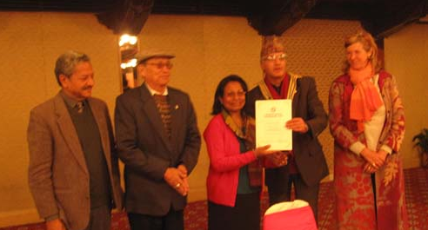
President Dr Som handing over certificate of appreciation to the Guest Speaker Dr Geetha Pfau
flanked by Asst. Governor PB Limbu and Membership Committee Chair Rtn Lisa.

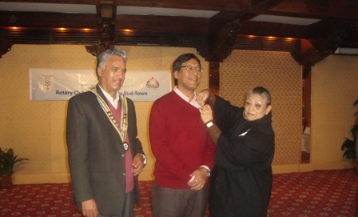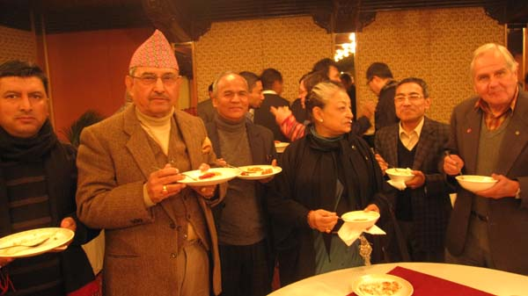
PP Ambica providing Rotary pin to Rtn Buddha Laishram Rotarians at breakfast fellowship after the meeting

Weekly Meetings and Programs :
Date | Program/Speaker | Program/Topics of Presentation
6 January 2012 | Dawa Steven Sherpa | Great Himalayan Trail

6 January, Friday:
Dawa Steven Sherpa will be providing a very interesting talk on Great Himalayan Trail. Don’t miss it !

District Conference:
4th District Conference of RI District 3292 is scheduled to be held at Biratnagar from 5th to 7th January 2012.
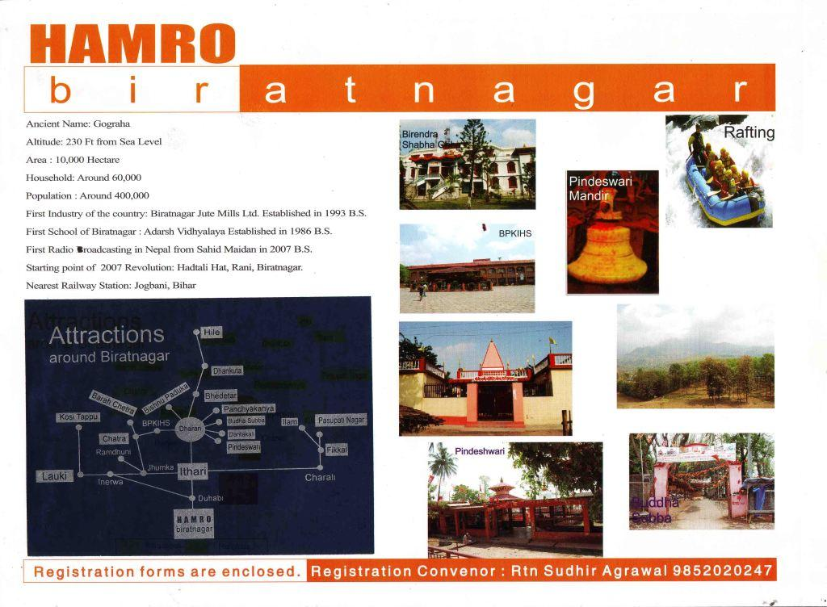
And the 5th District Conference ?
5th District Conference is planned to be held in Kathmandu in early 2013. The event is to be hosted by two clubs: RC Kathmandu Mid-Town and RC Bagmati.
For the purpose of information as well as for inviting Rotarians of all clubs to the event, a video clip was shot at Annapurna Hotel garden/ swimming pool area after the regular breakfast meeting on 30 Dec 2011. The message in the video is
“Welcome to Culturally and Heritage Rich Kathmandu Valley for the 5th District Conference”
The message was read in English by PP Ananda and in Nepali by President Som.
All Rotarians of Kathmandu Mid-Town who were present at, as well as those from RC Bagmati who attended the Friday morning meeting witnessed the video shooting, and participated in the process by chanting “Welcome, Welcome, Welcome” in both languages following PP Ananda and President Som.
President SK of RC Bagmati was also present during the shooting.
The video will be shown at the 4th District Conference being held at Biratnagar, 5-7 Jan 2012 as a part of our invitation to the 5th District Conference.
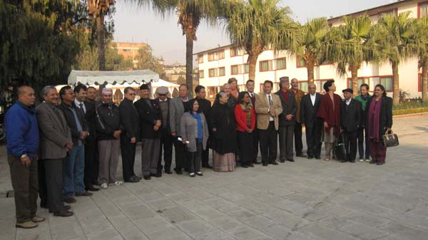
A group photo of RC Kathmandu Mid-Town and RC Bagmati,members after video shooting

Top five Rotary stories of 2011
From the tsunami in Japan to the launch of strategic partnerships that will help Rotary expand its reach, 2011 was an eventful year for Rotary International and Rotarians. As the year winds down, we share our list of the top five Rotary news events of 2011.
2. RI theme
RI President Kalyan Banerjee unveiled the 2011-12 RI theme, Reach Within to Embrace Humanity, during the International Assembly in January. He urged the Rotary leaders-in-training to harness their inner strength to achieve success in Rotary.
"In order to achieve anything in this world, a person has to use all the resources he can draw on. And the only place to start is with ourselves and within ourselves," Banerjee said.
Once Rotarians find their inner strength, he continued, they can accomplish great things in their communities and around the world.
"Discover yourself, develop the strengths within you, and then unhesitatingly, unflinchingly, go forth and encircle the world, to embrace humanity," he said.
Banerjee emphasized the family as a starting point in serving others. "The communities we live in are not built of individual people but of families -- families living in homes together, sharing their lives and their resources and their common destinies. Good families lead to good neighborhoods, and good neighborhoods build good communities."
Rotarians can focus on projects that support families, such as those that provide safe housing or improve maternal and child health, he said.
Continuity in Rotary’s work, including polio eradication, is also important, Banerjee said. "There are so many things we are indeed good at: working for clean, safe water; spreading literacy; working in so many ways with the New Generations, our youth, in our newest Avenue of Service and assisting them to become the leaders of tomorrow."
Citing Mahatma Gandhi’s call to "be the change you wish to see in the world," Banerjee said Rotarians should also focus on change.
"If we wish for peace, we start by living in peace ourselves, in our homes and in our communities," he explained. "If we wish environmental degradation to stop, if we wish to reduce child mortality or to prevent hunger, we must be the instrument of that change -- and recognize that it must start within us, with each of us."
(To be Cont’d) Source: Rotary International News

Too many people – intelligent, educated, involved people – simply have no idea what
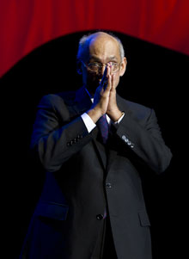
Rotary is. This is something we need to confront. We have heard again and again
about communities where, despite all the good work that Rotary clubs do, many
people are unaware that those clubs even exist. This is not the way forward for our
organization.
RI President Kalyan Banerjee

On Lighter Side :
Do you know?
Kathmandu is known as the world capital of typhoid fever among the health experts and
a few media specialists. A 2008 study published in the journal ‘Open Biology’ had described Kathmandu as a typhoid fever capital of the world. According to the research, community water spouts were the main sources of the outbreaks of typhoid in the valley.
Typhoid fever is a life-threatening illness caused by the bacterium Salmonella typhi.
It is common in the developing world where it affects about 22 million persons, mostly children below 15 years of age, each year. To avoid typhoid fever, either avoid risky food, drink or get vaccinated against it.
Boil it, cook it properly or forget it.
Source: The Rising Nepal

A THOUGHT FOR TODAY:
My own experience and development deepen every day my conviction that our moral progress may be measured by the degree in which we sympathize with individual suffering and individual joy.
George Eliot

Letter to the editor:
An email was received from DGE Yogendra Pradhan from San Diego, USA.
Dear PP RR:
I am now in Raliegh in US on the way to San Diego for the International Assembly. I am with my daughter and enjoying sort of Holidays before taking up the big challenge.
I have gone through the Breakfast Chatter and have enjoyed although you have tried your level best to make it very interesting, there are still some room for the improvements such as you could have given the coming
District Events i) Rotary Leadershhip Seminar - January 4th and ii) Disrict Conference 5th - 7th Jan in Biratnagar and the RYLA being hosted by Dhulikhel in first week of February etc.
I do hope you will not mind over my comments.
Best regards,
Yogi
Saturday, December 31, 2011

Please send project/activity information, suggestions and photos etc to :
BC Editor: RR Shrestha email: rryes@wlink.com.np

6 January 2012 The Weekly Bulletin of Rotary Club of Kathmandu Mid-Town bc-1.06/011-12

